Q. **What is hoisting?**

1. Hoisting refers to the process whereby the interpreter appears to move the declaration of functions, variables or classes to the top of their scope, prior to execution of the code.

Q. **What is scoping?**

1. Scoping is determining where variables, functions, and objects are accessible in your code during runtime. This means the scope of a variable.

Q. **How are var, let const different?**

1. var declarations are globally scoped or function scoped while let and const are block scoped. var variables can be updated and re-declared within its scope; let variables can be updated but not re-declared; const variables can neither be updated nor re-declared.

Q. **What are the two main differences in arrow functions?**



Q. **Does Call apply bind work for arrow functions?**

1. In case of arrow functions our methods: Call/Apply & Bind doesn't work as expected.

Q. **What does call apply bind do?**

1. The call() and apply() are very similar methods. They both execute the bound function on the object immediately. The bind() method does not execute the function right away. Instead, it creates and returns a bound function that can be executed later.

Q. **What are closures?**

1. Closure is a technique for implementing lexically scoped name binding in a language with first-class functions. Operationally, a closure is a record storing a function together with an environment.

Q. **Write a program to debounce a search bar?**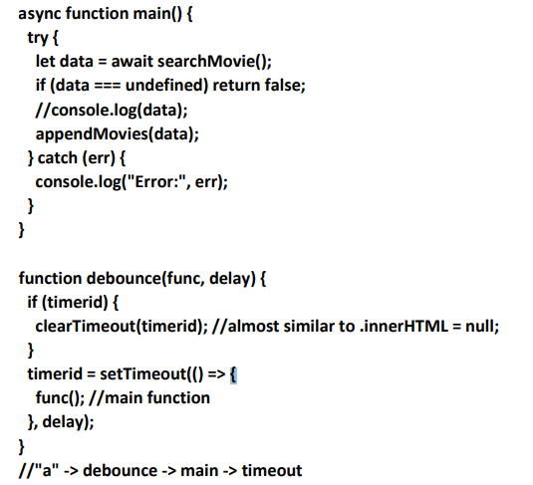

Q. **Write a program to throttle a search bar?**

Q. **What is event bubbling?**

1. Event bubbling is a type of event propagation where the event first triggers on the innermost target element, and then successively triggers on the ancestors of the target element in the same nesting hierarchy till it reaches the outermost DOM element or document object.

Q. **What is event loop?**

1. The event loop is a programming construct or design pattern that waits for and dispatches events or messages in a program. The event loop works by making a request to some internal or external "event provider", then calls the relevant event handler.

Q. **what does async await mean?**

1. The async/await pattern is a syntactic feature of many programming languages that allows an asynchronous, non-blocking function to be structured in a way similar to an ordinary synchronous function.

Q. **What does the this keyword mean?**

1. this is the reserved keyword which refers to the current instance of the method in which it is used.

Q. **What are classes? what are getters and setters?**

1. A JavaScript class is a blueprint for creating objects. A class encapsulates data and functions that manipulate data.
2. A mutator method is a method used to control changes to a variable. They are also widely known as setter methods. Often a setter is accompanied by a getter, which returns the value of the private member variable.

Q. **How do you declare private and static variables in classes?**

1. To declare a static variable we add static in front of the variable.

static variable=””;

Q. **What is currying?**

1. Currying is the technique of converting a function that takes multiple arguments into a sequence of functions that each takes a single argument.